|  |  |
| --- | --- |
| **D:\CE\WhatsApp Image 2021-05-08 at 4.35.03 PM.jpeg**    ***“CULTIVATING EXCELLENCE IN EVERY STUDENT”***  **‘**  **RAKESH KUMAR**  **M.Sc. (Chemistry) B.Ed.**  **CTET, PSTET, HPTET qualified**  **thakurkumar82@gmail.comA taste of technology | News Centre - Official news site of Calderdale  Councilhttp://chemistryexpert.in/** |  |
| **Class:-XII (Sci.) Name of Student……………………**  **Subject:- Chemistry**  **10 year QuStions**  **Chapter-14**  **Biomolecules** |  |

1. What happens when D-glucose is treated with the following? Give equations to support your answer. (a) HI (b) HNO3
2. Give any two points of difference between globular and fibrous proteins.
3. Write two differences between DNA and RNA.
4. (a) Give any one property of glucose that cannot be explained by the open chain structure. (b) Compare amylase with amylopectin in terms of constituting structure. (c) Why do amino acids show amphoteric behavior?
5. What is the difference between a glycosidic linkage and a peptide linkage?
6. What is the difference between Nucleotide and Nucleoside?
7. Write the products obtained after hydrolysis of DNA.
8. Define the following terms : (a) Invert sugar (b) Native protein (c) Nucleotide
9. (a) What are the products of hydrolysis of maltose? -helix structure ofα(b) What type of bonding provides stability to protein ? (c) Name the vitamin whose deficiency causes pernicious anaemia.
10. What is the basic structural difference between glucose and fructose?
11. Write the products obtained after hydrolysis of lactose.
12. Write chemical reactions to show that open structure of D-glucose contains the following : (i) Straight chain (ii) Five alcohol groups (iii) Aldehyde as carbonyl group
13. 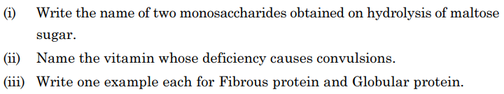

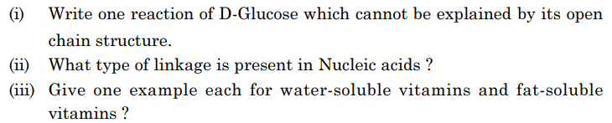



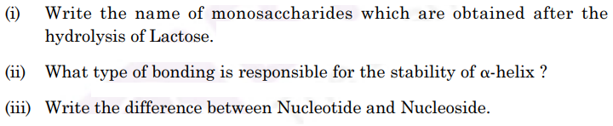

2. Why Vitamin C cannot be stored in our body?
3. Define the following terms in relation to proteins: (i) Peptide linkage (ii) Denaturation.
4. Explain the meaning of the following terms: (i) Invert sugar (ii) Polypeptides (iii) Enzymes
5. Write any two reactions of glucose which cannot be explained by the open chain structure of glucose molecules.
6. Explain Pyranose structure of glucose.
7. Describe what you understand by primary structure and secondary structure of proteins.
8. What is essentially the difference between a-form of glucose and b-form of glucose? Explain.
9. What are monosaccharides?
10. Name the products of hydrolysis of sucrose. Why is sucrose not a reducing sugar?
11. Name the four bases present in DNA. Which one of these is not present in RNA?
12. Name two fat soluble vitamins, their sources and the diseases caused due to their deficiency in diet.
13. Name two water soluble vitamins, their sources and the diseases caused due to their deficiency in diet.

**……………………**